Neurodivergent Burnout Symptom Tracker

This tracker is designed to help you spot patterns within your burnout and help you take small steps towards recovery.
Fill out all, part, or none of it. You’re in control! Nobody’s gonna check your work, I promise.
You can use this daily, weekly, or when you notice symptoms. It’s up to you! If you find yourself getting overwhelmed, come back to it later. You can fill in what you remember or just leave it blank.

- The Daily Tracker is set up to help you gauge your mood, motivation, and masking,, celebrate your wins, help you reflect, and make small, doable goals.
- The weekly Symptom Tracker is designed to help you take note of your symptoms and spot trends.
- Emotion Check-In supports you if you have trouble identifying your emotions (Hi, alexithymia) You can mark all that apply, even if they conflict.

Having this handy will help your health team make better, more informed decisions towards your care. You can take some or all of this to appointments if you can’t find the words.

You can use and customize this tracker however you need to:

- Save the file as a template on your computer or cloud storage (file-> Save a Copy in Google Doc/MS Word)
- Copy/Paste the pages you want to use into a separate doc
- Print out the pages you want to use
- Customize it into a digital journal that works for you

Remember to hydrate, take your meds, and eat something.
Bonus points: brushing your hair, teeth, or showering
You’re doing your best and that’s all that matters.

This tracker is meant to support your self-care, not replace medical or psychological care. If you’re in crisis, please reach out to your medical team, a safe person, or emergency services.

Want to customize your journal and keep the colors? Here’s the hex codes::
098C54 | GREEN |  | EE4266 | PINK
540D6E | PURPLE |  | FFD23F | YELLOW

📎 Copyright & Usage Info
This tracker was created by Amy White for Amy Writes Things and is intended for personal use only.

You’re welcome to use it, print it, or share the original download link with others who might benefit—but please don’t resell, repackage, or claim it as your own work.
If you’d like to feature it, collaborate, or ask about licensing, reach out to me directly.

Date

Fill out in the final row

How does this compare to yesterday?

Better
Worse

About the same

Mood | Motivation | Masking
1- Awful | 1- Awful | 1- Constant
2- Bad | 2- Bad | 2- Frequently
3- Meh | 3- Meh | 3- Mostly
4- Good | 4- Good | 4- Occasionally
5- Great! | 5- Great! | 5- None

Self Reflection
Why was today better or worse?
Is there anything you’d like to change for a better tomorrow?

Progress is made with small steps.

Wins
No matter how small or insignificant the task, what did you do today that you wanted to do?

Symptom Checklist

Place a check, “y”, or “x” for each symptom you’re experiencing

Week of:
 | 1 | 2 | 3 | 4 | 5 | 6 | 7
Energy
Struggled to get out of bed
Tired after a full night’s sleep
Feeling drained
Can’t start tasks that need to get done
Skipping meals, forgetting hygiene
Emotions
Irritable
Flat speech or feeling numb
Anxious over small things
Feeling helpless, guilty, anxious
Easily overwhelmed
Sensory/Cognitive
Overwhelmed by sights, sounds, or smells
Brain fog
Forgetting or zoning out during tasks
Can’t find words for what you want/need
Shutdowns/Meltdowns
 | 1 | 2 | 3 | 4 | 5 | 6 | 7
Social
Avoiding talking to people (inc. text/DM)
Masking is harder
Trouble making plans/canceling plans
Feeling disconnected or misunderstood
Trouble setting or upholding boundaries
Physical
Feeling more pain or tension in my body
Nausea, can’t eat, or eating too much
Racing heart, shallow breathing
Feeling tired and weak
Chronic illness flares

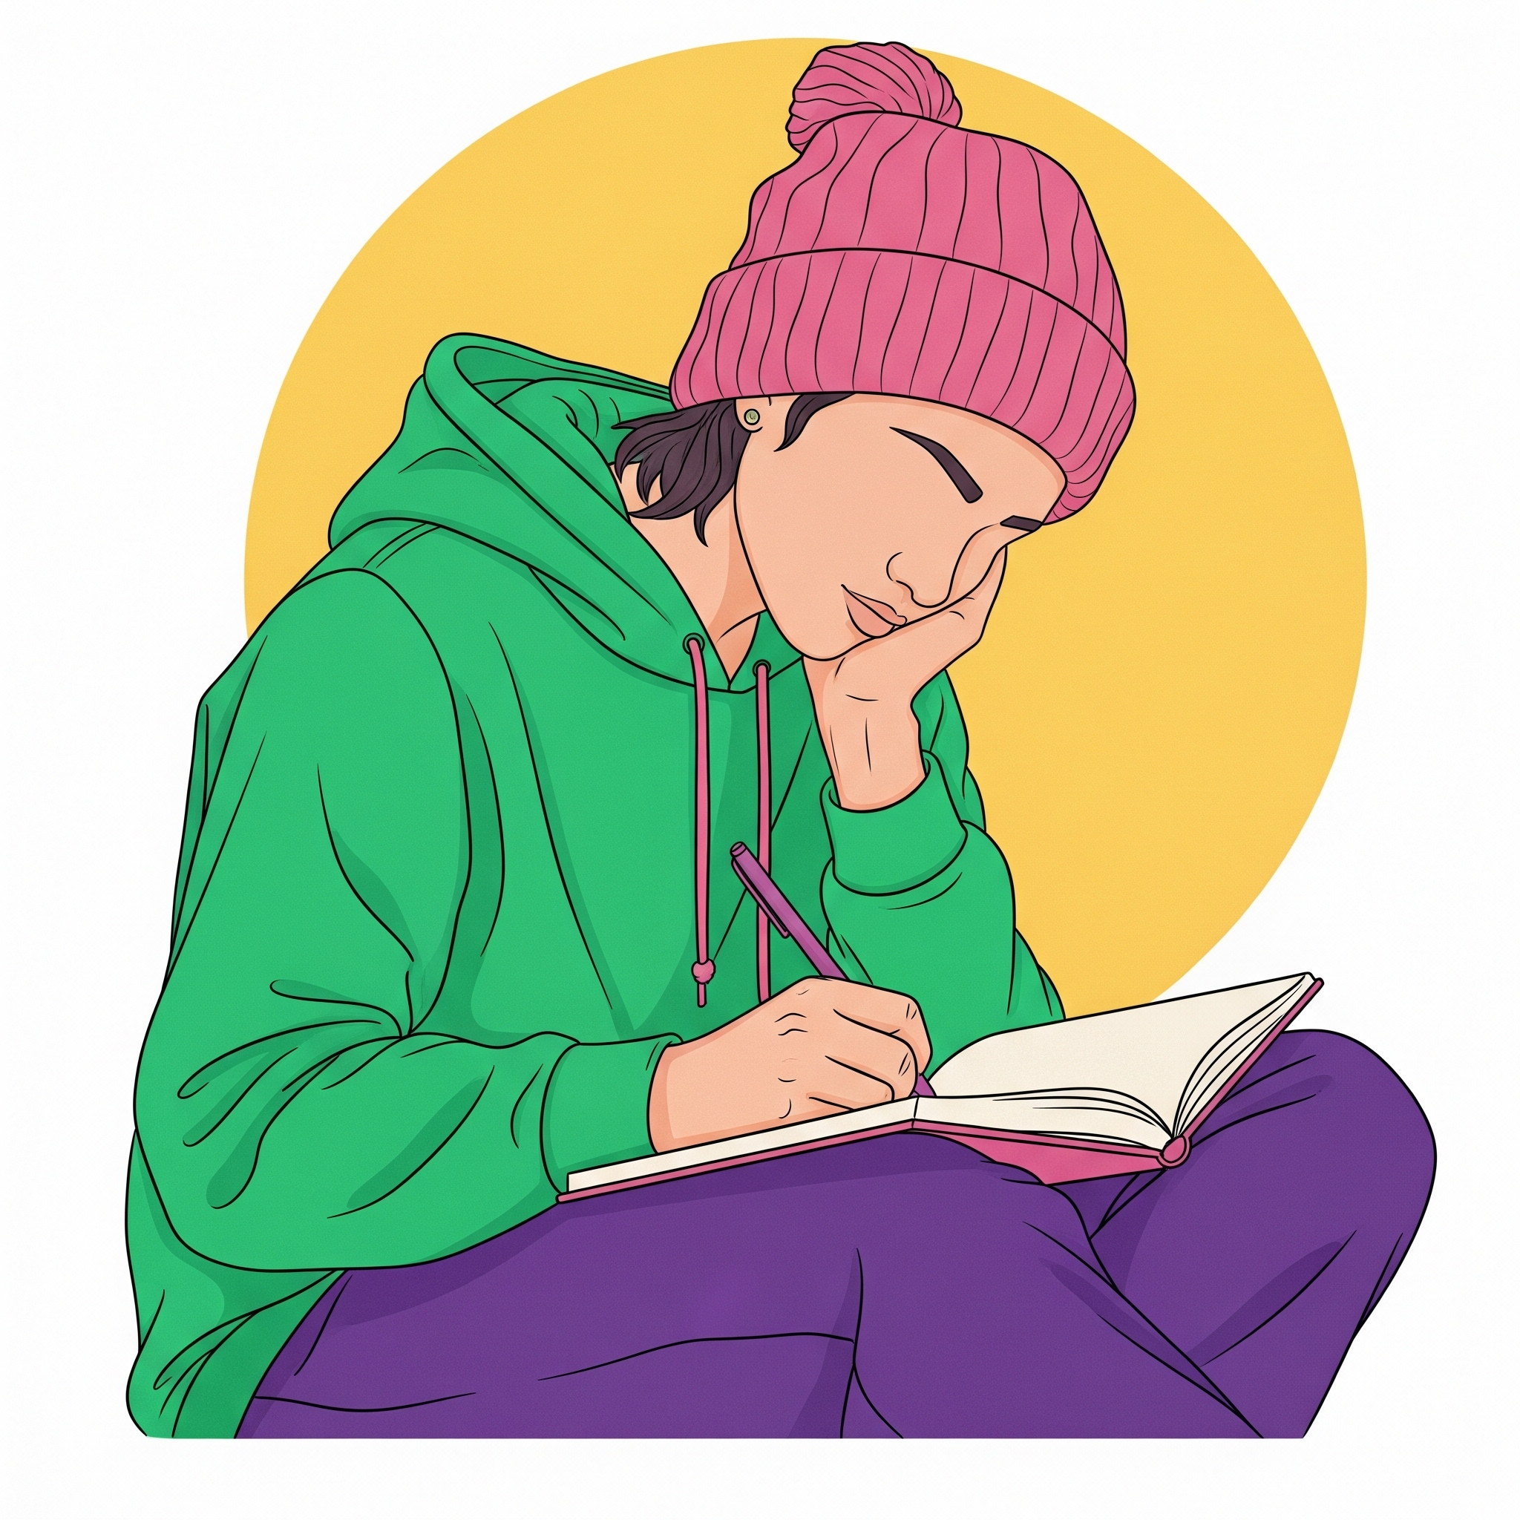

Emotional Check-In
Choose as many as you need to.

Happy
 | Content |  | Confident |  | Excited |  | Hopeful
 | Cheerful |  | Silly |  | Enthusiastic |  | Optimistic
 | Proud |  | Energetic |  | Eager |  | Elated
Surprised
 | Startled |  | Overwhelmed |  | Amazed |  | Crushed
 | Confused |  | Speechless |  | Moved |  | Stunned
 | Shocked |  | Curious |  | Awestruck |  | Bewildered
Peaceful
 | Calm |  | Trusting |  | Caring |  | Valued
 | Loving |  | Relaxed |  | Thankful |  | Inspired
 | Affectionate |  | Thoughtful |  | Accepted |  | Passionate
Sad
 | Bored |  | Guilty |  | Insignificant |  | Hopeless
 | Tired |  | Disappointed |  | Inferior |  | Devastated
 | Lonely |  | Hurt |  | Rejected |  | Miserable
Angry
 | Mad |  | Irritated |  | Hostile |  | Furious
 | Offended |  | Frustrated |  | Enraged |  | Hateful
 | Jealous |  | Annoyed |  | Agitated |  | Disgusted
Fearful
 | Excluded |  | Worried |  | Panic |  | Scared
 | Regretful |  | Nervous |  | Terrified |  | Embarrassed
 | Anxious |  | Shy |  | Frightened |  | Insecure
